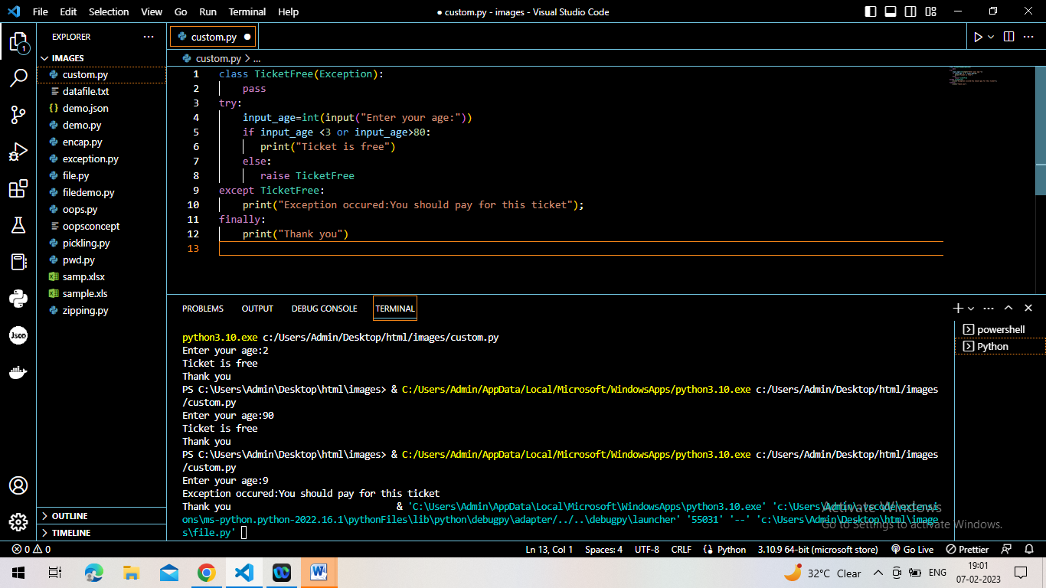2)Date validation for booking tickets 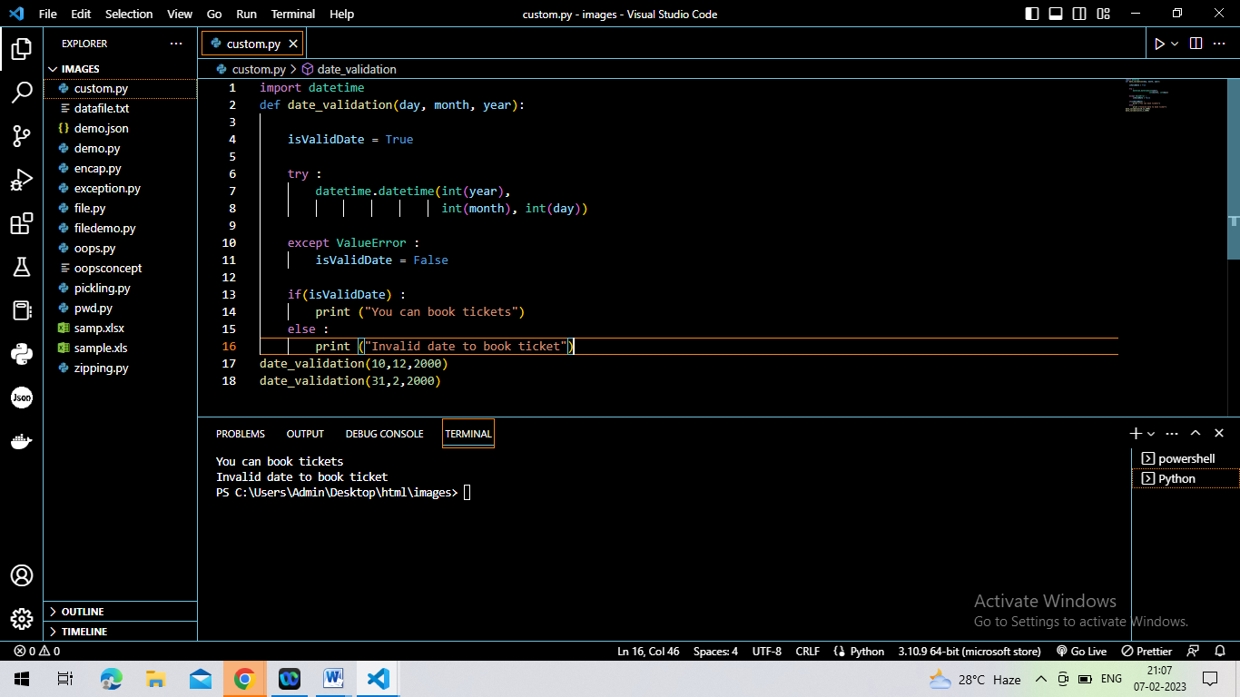

**Exceptions**

3.Ticket is free for <3 and morethan 80

1. Password should not be blank and it must have 8 characters

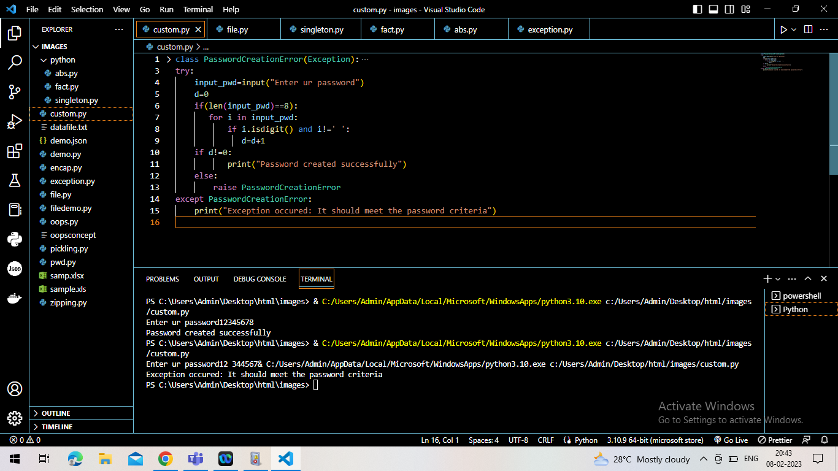

By:

PAVITHRA V